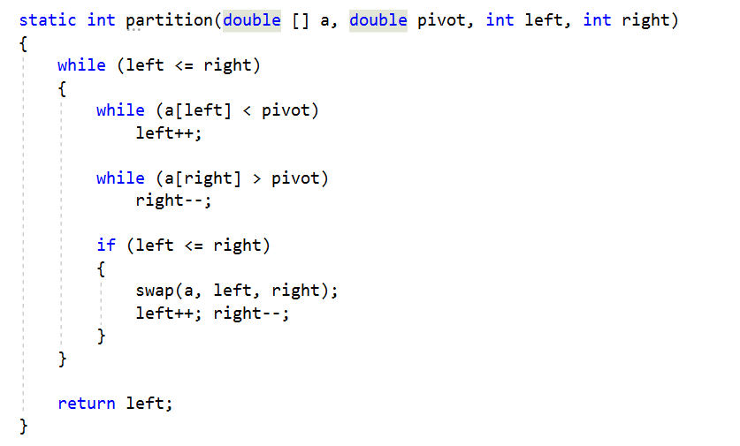
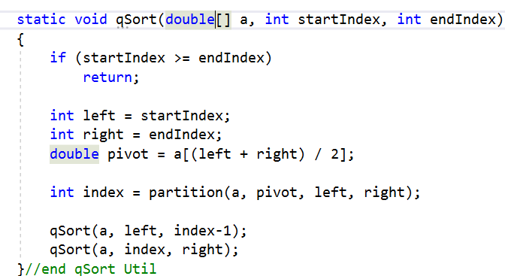
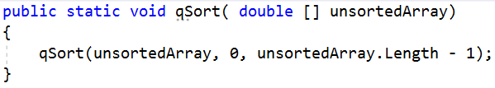
1
24
57
12
9
left
right
Pivot: 1
Qsort left: 0
Qsort right: 1
Qsort index: _
Stack: Lvl: 0
Left: 0 Right: 4
Stack: Lvl: 1
Left: 0 Right: 3
Stack: Lvl: 2
Left: 0 Right: 2
Stack: Lvl: 2
Left: 0 Right: 1
From: https://www.youtube.com/watch?v=SLauY6PpjW4

